Associate Data Practitioner

- You created a customer support application that sends several forms of data to Google Cloud. Your application is sending:

- Audio files from phone interactions with support agents that will be accessed during trainings.
- CSV files of users' personally identifiable information (Pll) that will be analyzed with SQL.
- A large volume of small document files that will power other applications.

You need to select the appropriate tool for each data type given the required use case, while following Google-recommended practices. Which should you choose?

- 1. Cloud Storage
2. CloudSQL for PostgreSQL
3. Bigtable
- 1. Filestore
2. Cloud SQL for PostgreSQL
3. Datastore
- 1. Cloud Storage
2. BigQuery
3. Firestore
- 1. Filestore
2. Bigtable
3. BigQuery
- Audio files: Cloud Storage is ideal for storing large files like audio.
- CSV files: BigQuery is suitable for analyzing large datasets with SQL.
- Document files: Firestore is great for handling a large volume of small documents.

- You are migrating data from a legacy on-premises MySQL database to Google Cloud. The database contains various tables with different data types and sizes, including large tables with millions of rows and transactional data. You need to migrate this data while maintaining data integrity and minimizing downtime and cost. What should you do?

- Set up a Cloud Composer environment to orchestrate a custom data pipeline. Use a Python script to extract data from the MySQL database and load it to MySQL on Compute Engine.
- Export the MySQL database to CSV files, transfer the files to Cloud Storage by using Storage Transfer Service, and load the files into a Cloud SQL for MySQL instance.
- Use Database Migration Service to replicate the MySQL database to a Cloud SQL for MySQL instance.
- Use Cloud Data Fusion to migrate the MySQL database to MySQL on Compute Engine.
Database Migration Service is designed specifically for migrating databases to Google Cloud. It streamlines the process by managing the initial snapshot and ongoing replication, ensuring minimal downtime and maintaining data integrity.

- You work for a global financial services company that trades stocks 24/7. You have a Cloud SGL for PostgreSQL user database. You need to identify a solution that ensures that the database is continuously operational, minimizes downtime, and will not lose any data in the event of a zonal outage. What should you do?

- Continuously back up the Cloud SGL instance to Cloud Storage. Create a Compute Engine instance with PostgreSQL in a different region. Restore the backup in the Compute Engine instance if a failure occurs.
- Create a read replica in another region. Promote the replica to primary if a failure occurs.
- Configure and create a high-availability Cloud SQL instance with the primary instance in zone A and a secondary instance in any zone other than zone A.
- Create a read replica in the same region but in a different zone.

- Configuring and creating a high-availability Cloud SQL instance with the primary instance in zone A and a secondary instance in any zone other than zone A ensures redundancy and failover capabilities
- This setup allows the database to remain operational even if one zone experiences an outage, minimizing downtime and ensuring data integrity.

- Your organization has a BigQuery dataset that contains sensitive employee information such as salaries and performance reviews. The payroll specialist in the HR department needs to have continuous access to aggregated performance data, but they do not need continuous access to other sensitive data. You need to grant the payroll specialist access to the performance data without granting them access to the entire dataset using the simplest and most secure approach. What should you do?

- Use authorized views to share query results with the payroll specialist.
- Create row-level and column-level permissions and policies on the table that contains performance data in the dataset. Provide the payroll specialist with the appropriate permission set.
- Create a table with the aggregated performance data. Use table-level permissions to grant access to the payroll specialist.
- Create a SQL query with the aggregated performance data. Export the results to an Avro file in a Cloud Storage bucket. Share the bucket with the payroll specialist.

- Authorized views allow you to share specific query results with the payroll specialist without giving them access to the underlying sensitive data.
- This method ensures that the payroll specialist can continuously access the necessary aggregated performance data while maintaining the security and privacy of other sensitive information.
- Your team uses the Google Ads platform to visualize metrics. You want to export the data to BigQuery to get more granular insights. You need to execute a one-time transfer of historical data and automatically update data daily. You want a solution that is low-code, serverless, and requires minimal maintenance. What should you do?

- Export the historical data to BigQuery by using BigQuery Data Transfer Service. Use Cloud Composer for daily automation.
- Export the historical data to Cloud Storage by using Storage Transfer Service. Use Pub/Sub to trigger a Dataflow template that loads data for daily automation.
- Export the historical data as a CSV file. Import the file into BigQuery for analysis. Use Cloud Composer for daily automation.
- Export the historical data to BigQuery by using BigQuery Data Transfer Service. Use BigQuery Data Transfer Service for daily automation.

- BigQuery Data Transfer Service allows you to easily transfer historical data to BigQuery.
- It also supports automatic daily updates, ensuring that your data is kept up-to-date without requiring additional automation tools.

- Your retail company wants to predict customer churn using historical purchase data stored in BigQuery. The dataset includes customer demographics, purchase history, and a label indicating whether the customer churned or not. You want to build a machine learning model to identify customers at risk of churning. You need to create and train a logistic regression model for predicting customer churn, using the customer_data table with the churned column as the target label. Which BigQuery ML query should you use?

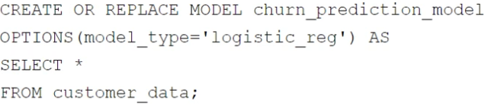

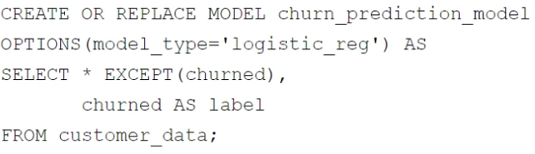

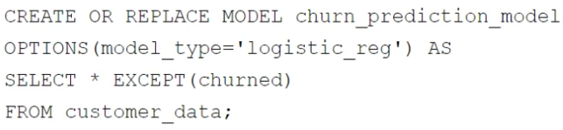

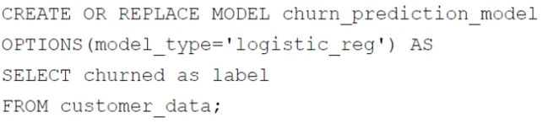
- Your company has several retail locations. Your company tracks the total number of sales made at each location each day. You want to use SQL to calculate the weekly moving average of sales by location to identify trends for each store. Which query should you use?

  - 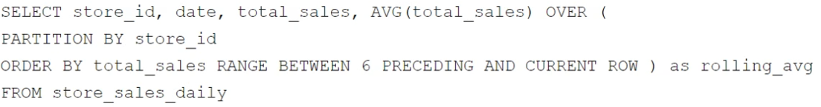
  - 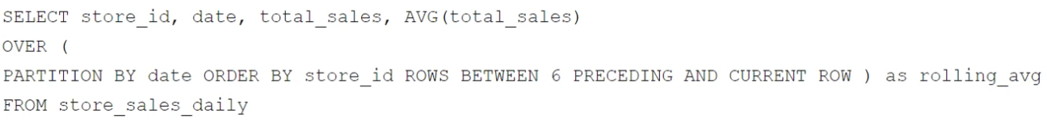
  - 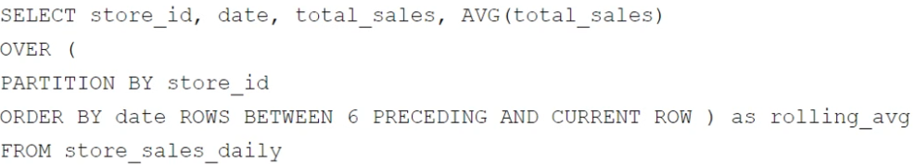
  - 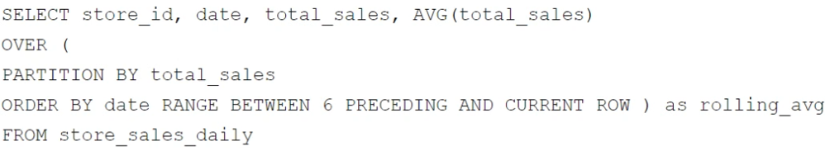
- Your company is building a near real-time streaming pipeline to process JSON telemetry data from small appliances. You need to process messages arriving at a Pub/Sub topic, capitalize letters in the serial number field, and write results to BigQuery. You want to use a managed service and write a minimal amount of code for underlying transformations. What should you do?

  - Use a Pub/Sub to BigQuery subscription, write results directly to BigQuery, and schedule a transformation query to run every five minutes.
  - Use a Pub/Sub to Cloud Storage subscription, write a Cloud Run service that is triggered when objects arrive in the bucket, performs the transformations, and writes the results to BigQuery.
  - Use the “Pub/Sub to BigQuery” Dataflow template with a UDF, and write the results to BigQuery.
  - Use a Pub/Sub push subscription, write a Cloud Run service that accepts the messages, performs the transformations, and writes the results to BigQuery.

- Dataflow is a fully managed service for stream and batch processing.
- Using the “Pub/Sub to BigQuery” Dataflow template allows you to process messages from Pub/Sub, apply transformations using a User-Defined Function (UDF), and write the results directly to BigQuery.

- You want to process and load a daily sales CSV file stored in Cloud Storage into BigQuery for downstream reporting. You need to quickly build a scalable data pipeline that transforms the data while providing insights into data quality issues. What should you do?

  - Create a batch pipeline in Cloud Data Fusion by using a Cloud Storage source and a BigQuery sink.
  - Load the CSV file as a table in BigQuery, and use scheduled queries to run SQL transformation scripts.
  - Load the CSV file as a table in BigQuery. Create a batch pipeline in Cloud Data Fusion by using a BigQuery source and sink.
  - Create a batch pipeline in Dataflow by using the Cloud Storage CSV file to BigQuery batch template.

- Cloud Data Fusion allows you to create a batch pipeline with a Cloud Storage source and a BigQuery sink.
- This setup enables you to process and transform the CSV data efficiently while monitoring data quality.

- You manage a Cloud Storage bucket that stores temporary files created during data processing. These temporary files are only needed for seven days, after which they are no longer needed. To reduce storage costs and keep your bucket organized, you want to automatically delete these files once they are older than seven days. What should you do?

  - Set up a Cloud Scheduler job that invokes a weekly Cloud Run function to delete files older than seven days.
  - Configure a Cloud Storage lifecycle rule that automatically deletes objects older than seven days.
  - Develop a batch process using Dataflow that runs weekly and deletes files based on their age.
  - Create a Cloud Run function that runs daily and deletes files older than seven days.

- Cloud Storage lifecycle rules allow you to automatically manage the lifecycle of your objects, including deleting objects older than a specified number of days.

- You work for a healthcare company that has a large on-premises data system containing patient records with personally identifiable information (PII) such as names, addresses, and medical diagnoses. You need a standardized managed solution that de-identifies PII across all your data feeds prior to ingestion to Google Cloud. What should you do?

  - Use Cloud Run functions to create a serverless data cleaning pipeline. Store the cleaned data in BigQuery.
  - Use Cloud Data Fusion to transform the data. Store the cleaned data in BigQuery.
  - Load the data into BigQuery, and inspect the data by using SQL queries. Use Dataflow to transform the data and remove any errors.
  - Use Apache Beam to read the data and perform the necessary cleaning and transformation operations. Store the cleaned data in BigQuery.

- Cloud Data Fusion provides a managed, visual interface for building data pipelines, including transformations for de-identifying PII.
- It allows you to standardize the de-identification process across all data feeds before storing the cleaned data in BigQuery.

- You manage a large amount of data in Cloud Storage, including raw data, processed data, and backups. Your organization is subject to strict compliance regulations that mandate data immutability for specific data types. You want to use an efficient process to reduce storage costs while ensuring that your storage strategy meets retention requirements. What should you do?

  - Configure lifecycle management rules to transition objects to appropriate storage classes based on access patterns. Set up Object Versioning for all objects to meet immutability requirements.
  - Move objects to different storage classes based on their age and access patterns. Use Cloud Key Management Service (Cloud KMS) to encrypt specific objects with customer-managed encryption keys (CMEK) to meet immutability requirements.
  - Create a Cloud Run function to periodically check object metadata, and move objects to the appropriate storage class based on age and access patterns. Use object holds to enforce immutability for specific objects.
  - Use object holds to enforce immutability for specific objects, and configure lifecycle management rules to transition objects to appropriate storage classes based on age and access patterns.

- Object holds can be used to enforce immutability for specific objects, ensuring they cannot be deleted or overwritten.
- Lifecycle management rules can transition objects to appropriate storage classes based on their age and access patterns, optimizing storage costs.

- You work for an ecommerce company that has a BigQuery dataset that contains customer purchase history, demographics, and website interactions. You need to build a machine learning (ML) model to predict which customers are most likely to make a purchase in the next month. You have limited engineering resources and need to minimize the ML expertise required for the solution. What should you do?

  - Use BigQuery ML to create a logistic regression model for purchase prediction.
  - Use Vertex AI Workbench to develop a custom model for purchase prediction.
  - Use Colab Enterprise to develop a custom model for purchase prediction.
  - Export the data to Cloud Storage, and use AutoML Tables to build a classification model for purchase prediction.
- BigQuery ML enables you to create a logistic regression model for purchase prediction with minimal coding and ML expertise required.

- You are designing a pipeline to process data files that arrive in Cloud Storage by 3:00 am each day. Data processing is performed in stages, where the output of one stage becomes the input of the next. Each stage takes a long time to run. Occasionally a stage fails, and you have to address the problem. You need to ensure that the final output is generated as quickly as possible. What should you do?

  - Design a Spark program that runs under Dataproc. Code the program to wait for user input when an error is detected. Rerun the last action after correcting any stage output data errors.
  - Design the pipeline as a set of PTransforms in Dataflow. Restart the pipeline after correcting any stage output data errors.
  - Design the workflow as a Cloud Workflow instance. Code the workflow to jump to a given stage based on an input parameter. Rerun the workflow after correcting any stage output data errors.
  - Design the processing as a directed acyclic graph (DAG) in Cloud Composer. Clear the state of the failed task after correcting any stage output data errors.

- Cloud Composer allows you to design the processing as a directed acyclic graph (DAG), which is well-suited for managing complex workflows with dependencies.
- You can clear the state of the failed task and rerun it after correcting any errors, ensuring that the pipeline continues from where it left off without having to restart the entire process.

- Another team in your organization is requesting access to a BigQuery dataset. You need to share the dataset with the team while minimizing the risk of unauthorized copying of data. You also want to create a reusable framework in case you need to share this data with other teams in the future. What should you do?

  - Create authorized views in the team’s Google Cloud project that is only accessible by the team.
  - Create a private exchange using Analytics Hub with data egress restriction, and grant access to the team members.
  - Enable domain restricted sharing on the project. Grant the team members the BigQuery Data Viewer IAM role on the dataset.
  - Export the dataset to a Cloud Storage bucket in the team’s Google Cloud project that is only accessible by the team.

- Analytics Hub allows you to create a private exchange with data egress restrictions, ensuring that the data cannot be copied or exported unauthorizedly.
- This approach provides a secure and controlled way to share datasets with other teams and can be reused for future data sharing needs.

- Your company has developed a website that allows users to upload and share video files. These files are most frequently accessed and shared when they are initially uploaded. Over time, the files are accessed and shared less frequently, although some old video files may remain very popular.
You need to design a storage system that is simple and cost-effective. What should you do?

  - Create a single-region bucket with Autoclass enabled.
  - Create a single-region bucket. Configure a Cloud Scheduler job that runs every 24 hours and changes the storage class based on upload date.
  - Create a single-region bucket with custom Object Lifecycle Management policies based on upload date.
  - Create a single-region bucket with Archive as the default storage class.

- Autoclass automatically transitions objects to the most cost-effective storage class based on their access patterns, without requiring manual intervention.
- This approach simplifies management and ensures cost efficiency as the access frequency of the files changes over time.

- You recently inherited a task for managing Dataflow streaming pipelines in your organization and noticed that proper access had not been provisioned to you. You need to request a Google-provided IAM role so you can restart the pipelines. You need to follow the principle of least privilege. What should you do?

  - Request the Dataflow Developer role.
  - Request the Dataflow Viewer role.
  - Request the Dataflow Worker role.
  - Request the Dataflow Admin role.

- The Dataflow Developer role provides the permissions necessary to execute and manipulate Dataflow jobs, including restarting pipelines

- You need to create a new data pipeline. You want a serverless solution that meets the following requirements:
• Data is streamed from Pub/Sub and is processed in real-time.
• Data is transformed before being stored.
• Data is stored in a location that will allow it to be analyzed with SQL using Looker.
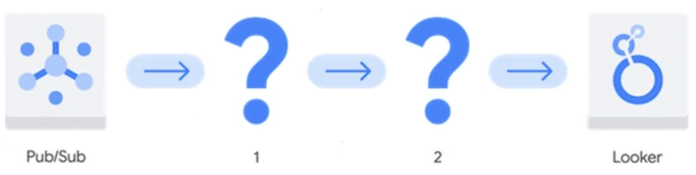
- Which Google Cloud services should you recommend for the pipeline?

  - 1. Dataproc Serverless
2. Bigtable
  - 1. Cloud Composer
2. Cloud SQL for MySQL
  - 1. BigQuery
2. Analytics Hub
  - 1. Dataflow
2. BigQuery

- Dataflow is a fully managed, serverless service for real-time stream processing and transformations.
- BigQuery is a serverless, highly scalable, and cost-effective multi-cloud data warehouse that supports SQL queries and integrates well with Looker for analysis.

- Your team wants to create a monthly report to analyze inventory data that is updated daily. You need to aggregate the inventory counts by using only the most recent month of data, and save the results to be used in a Looker Studio dashboard. What should you do?

  - Create a materialized view in BigQuery that uses the SUM( ) function and the DATE_SUB( ) function.
  - Create a saved query in the BigQuery console that uses the SUM( ) function and the DATE_SUB( ) function. Re-run the saved query every month, and save the results to a BigQuery table.
  - Create a BigQuery table that uses the SUM( ) function and the _PARTITIONDATE filter.
  - Create a BigQuery table that uses the SUM( ) function and the DATE_DIFF( ) function.

- Materialized views in BigQuery are precomputed views that store the results of a query. They are efficient for aggregating data and can be refreshed automatically.
- Using the SUM() function and the DATE_SUB() function allows you to aggregate the inventory counts for the most recent month.

- You have a BigQuery dataset containing sales data. This data is actively queried for the first 6 months. After that, the data is not queried but needs to be retained for 3 years for compliance reasons. You need to implement a data management strategy that meets access and compliance requirements, while keeping cost and administrative overhead to a minimum. What should you do?

  - Use BigQuery long-term storage for the entire dataset. Set up a Cloud Run function to delete the data from BigQuery after 3 years.
  - Partition a BigQuery table by month. After 6 months, export the data to Coldline storage. Implement a lifecycle policy to delete the data from Cloud Storage after 3 years.
  - Set up a scheduled query to export the data to Cloud Storage after 6 months. Write a stored procedure to delete the data from BigQuery after 3 years.
  - Store all data in a single BigQuery table without partitioning or lifecycle policies.

- BigQuery long-term storage automatically reduces the cost of storing data that is not queried for 90 days, making it cost-effective for retaining data that is infrequently accessed.
- Setting up a Cloud Run function to delete the data after 3 years ensures compliance with retention policies without manual intervention.

- You have created a LookML model and dashboard that shows daily sales metrics for five regional managers to use. You want to ensure that the regional managers can only see sales metrics specific to their region. You need an easy-to-implement solution. What should you do?

  - Create a sales_region user attribute, and assign each manager’s region as the value of their user attribute. Add an access_filter Explore filter on the region_name dimension by using the sales_region user attribute.
  - Create five different Explores with the sql_always_filter Explore filter applied on the region_name dimension. Set each region_name value to the corresponding region for each manager.
  - Create separate Looker dashboards for each regional manager. Set the default dashboard filter to the corresponding region for each manager.
  - Create separate Looker instances for each regional manager. Copy the LookML model and dashboard to each instance. Provision viewer access to the corresponding manager.

- Creating a sales_region user attribute and assigning each manager’s region as the value of their user attribute allows you to control access based on user attributes.
- Adding an access_filter Explore filter on the region_name dimension using the sales_region user attribute ensures that each manager only sees data relevant to their region.

- Your organization has a petabyte of application logs stored as Parquet files in Cloud Storage. You need to quickly perform a one-time SQL-based analysis of the files and join them to data that already resides in BigQuery. What should you do?

  - Create a Dataproc cluster, and write a PySpark job to join the data from BigQuery to the files in Cloud Storage.
  - Launch a Cloud Data Fusion environment, use plugins to connect to BigQuery and Cloud Storage, and use the SQL join operation to analyze the data.
  - Create external tables over the files in Cloud Storage, and perform SQL joins to tables in BigQuery to analyze the data.
  - Use the bq load command to load the Parquet files into BigQuery, and perform SQL joins to analyze the data.

- Creating external tables over the Parquet files in Cloud Storage allows you to query the data directly without needing to load it into BigQuery.
- You can then perform SQL joins with existing tables in BigQuery to analyze the data efficiently.

Creating external tables over the Parquet files in Cloud Storage allows you to perform SQL-based analysis and joins with data already in BigQuery without needing to load the files into BigQuery. This approach is efficient for a one-time analysis as it avoids the time and cost associated with loading large volumes of data into BigQuery. External tables provide seamless integration with Cloud Storage, enabling quick and cost-effective analysis of data stored in Parquet format.

- You need to create a data pipeline that streams event information from applications in multiple Google Cloud regions into BigQuery for near real-time analysis. The data requires transformation before loading. You want to create the pipeline using a visual interface. What should you do?

  - Push event information to a Pub/Sub topic. Create a Dataflow job using the Dataflow job builder.
  - Push event information to a Pub/Sub topic. Create a Cloud Run function to subscribe to the Pub/Sub topic, apply transformations, and insert the data into BigQuery.
  - Push event information to a Pub/Sub topic. Create a BigQuery subscription in Pub/Sub.
  - Push event information to Cloud Storage, and create an external table in BigQuery. Create a BigQuery scheduled job that executes once each day to apply transformations.

- Pushing event information to a Pub/Sub topic ensures that the data is streamed in real-time.
- Creating a Dataflow job using the Dataflow job builder allows you to visually design the pipeline, apply necessary transformations, and load the data into BigQuery.
Pushing event information to a Pub/Sub topic and then creating a Dataflow job using the Dataflow job builder is the most suitable solution. The Dataflow job builder provides a visual interface to design pipelines, allowing you to define transformations and load data into BigQuery. This approach is ideal for streaming data pipelines that require near real-time transformations and analysis. It ensures scalability across multiple regions and integrates seamlessly with Pub/Sub for event ingestion and BigQuery for analysis.

- Your organization uses scheduled queries to perform transformations on data stored in BigQuery. You discover that one of your scheduled queries has failed. You need to troubleshoot the issue as quickly as possible. What should you do?

  - Navigate to the Logs Explorer page in Cloud Logging. Use filters to find the failed job, and analyze the error details.
  - Set up a log sink using the gcloud CLI to export BigQuery audit logs to BigQuery. Query those logs to identify the error associated with the failed job ID.
  - Request access from your admin to the BigQuery information_schema. Query the jobs view with the failed job ID, and analyze error details.
  - Navigate to the Scheduled queries page in the Google Cloud console. Select the failed job, and analyze the error details.

- Navigating to the Scheduled queries page in the Google Cloud console allows you to directly access the details of the failed job.
- You can select the failed job and analyze the error details immediately, which helps in identifying and resolving the issue quickly.
- Your team is building several data pipelines that contain a collection of complex tasks and dependencies that you want to execute on a schedule, in a specific order. The tasks and dependencies consist of files in Cloud Storage, Apache Spark jobs, and data in BigQuery. You need to design a system that can schedule and automate these data processing tasks using a fully managed approach. What should you do?

  - Use Cloud Scheduler to schedule the jobs to run.
  - Use Cloud Tasks to schedule and run the jobs asynchronously.
  - Create directed acyclic graphs (DAGs) in Cloud Composer. Use the appropriate operators to connect to Cloud Storage, Spark, and BigQuery.
  - Create directed acyclic graphs (DAGs) in Apache Airflow deployed on Google Kubernetes Engine. Use the appropriate operators to connect to Cloud Storage, Spark, and BigQuery.

- Cloud Composer is a fully managed workflow orchestration service built on Apache Airflow.
- Creating directed acyclic graphs (DAGs) in Cloud Composer allows you to schedule and automate tasks in a specific order.
- You can use the appropriate operators to connect to Cloud Storage, Spark, and BigQuery, ensuring seamless integration and execution of your data pipelines.

Using Cloud Composer to create Directed Acyclic Graphs (DAGs) is the best solution because it is a fully managed, scalable workflow orchestration service based on Apache Airflow. Cloud Composer allows you to define complex task dependencies and schedules while integrating seamlessly with Google Cloud services such as Cloud Storage, BigQuery, and Dataproc for Apache Spark jobs. This approach minimizes operational overhead, supports scheduling and automation, and provides an efficient and fully managed way to orchestrate your data pipelines.

- You are constructing a data pipeline to process sensitive customer data stored in a Cloud Storage bucket. You need to ensure that this data remains accessible, even in the event of a single-zone outage. What should you do?

  - Set up a Cloud CDN in front of the bucket.
  - Enable Object Versioning on the bucket.
  - Store the data in a multi-region bucket.
  - Store the data in Nearline storaqe.

- Storing the data in a multi-region bucket ensures high availability and redundancy across multiple geographic locations, making the data accessible even if one zone experiences an outage.
Storing the data in a multi-region bucket ensures high availability and durability, even in the event of a single-zone outage. Multi-region buckets replicate data across multiple locations within the selected region, providing resilience against zone-level failures and ensuring that the data remains accessible. This approach is particularly suitable for sensitive customer data that must remain available without interruptions.

